Day 78-02 Azure Vault

Creation of the Key Vault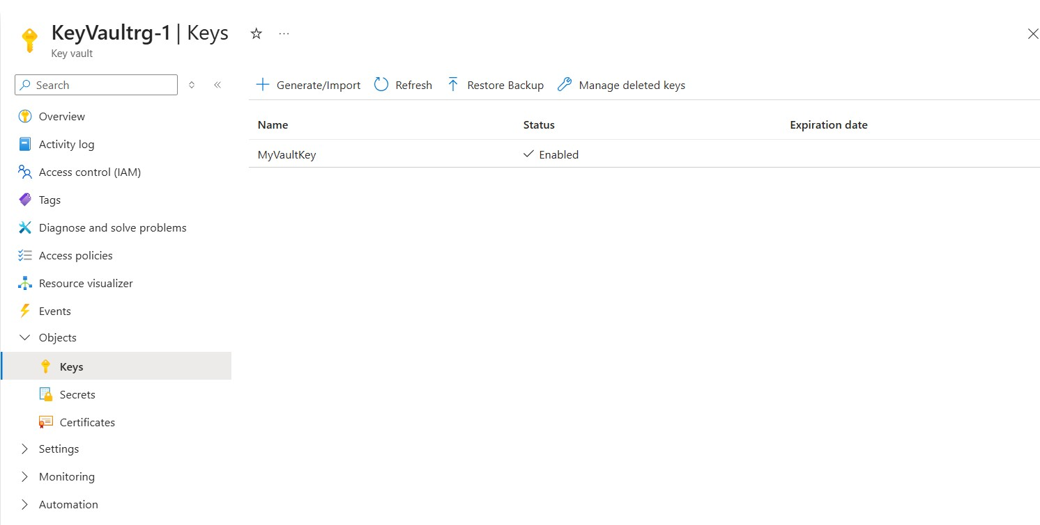

Creation of Secret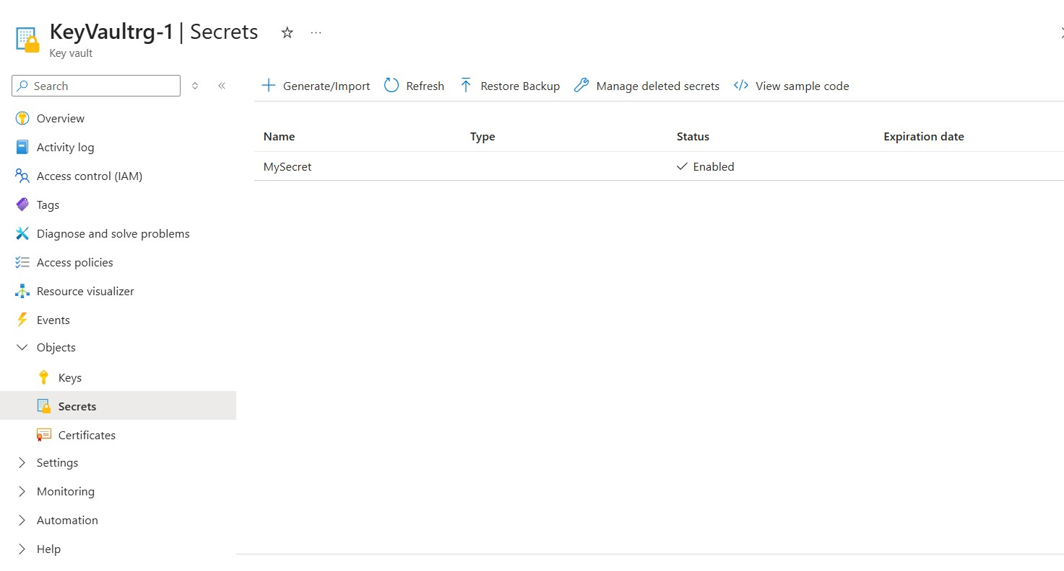
Creation of Keys

Output
